# Install multiple cinder volume servers

## Introduce

The OpenStack Block Storage service works through the interaction of a series of daemon processes named cinder-* that reside persistently on the host machine or machines. The binaries can all be run from a single node, or spread across multiple nodes. The default OpenStack Block Storage service implementation is an iSCSI solution that uses Logical Volume Manager (LVM) for Linux.

## Architecture



## Components

Controler node:

cinder-api

cinder-sheduler

cinder-volume

scsi-target-utils(rpm)

cinder-back node:

cinder-volume

scsi-target-utils(rpm)

compute node:

iscsi-initiator(rpm)

## Logic diagram

The logic diagram shows as below:

1. cinder-api received a request to create a volume from dashboard/cli
2. cinder-api write a message into rabbitmq server
3. cinder-scheduler obtained the message from rabbitmq server,and then selected the best suitable cinder-volume to create a volume



## Install cinder-backup

1.Installed openstack used packstack tool

2.Installed cinder-backup node

(1)Created /dev/loop1 to simulate another disk

dd if=/dev/zero of=/dxb_loop1 bs=1k count=10000000

losetup /dev/loop1 /dxb_loop1

(2)Created a physical volume

pvcreate /dev/loop1

(3)Created a volume group

vgcreare –s 4M cinder-volumes /dev/loop1

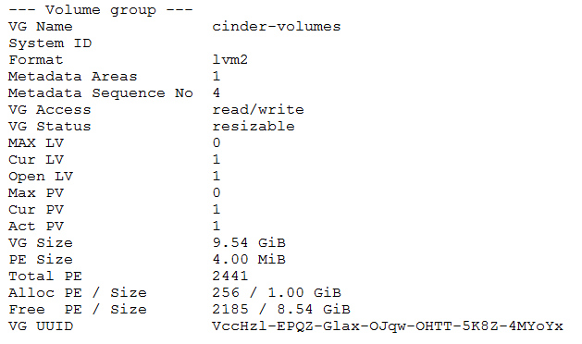

(4)Installed cinder-volume and scsi-target-utils

yum install -y openstack-cinder scsi-target-utils

(5)cp cinder.conf from controller node

scp root@10.228.254.143:/etc/cinder/cinder.conf /etc/cinder/

(6)modify cinder.conf

iscsi_ip_address=10.228.254.151

(6)modify the user and group about cinder.conf

chown cinder:cinder /etc/cinder/cinder.conf

(7) enable cinder-volume service

systemctl start openstack-cinder-volume

systemctl start tgtd

chkconfig openstack-cinder-volume on

chkconfig tgtd on

(8)check cinder-volume service on controller node, cinder-volume has been enabled on cinder-back node.

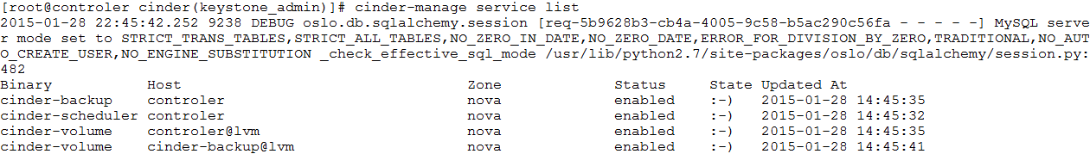

## Create volumes

### Add multiple volumes on openstack

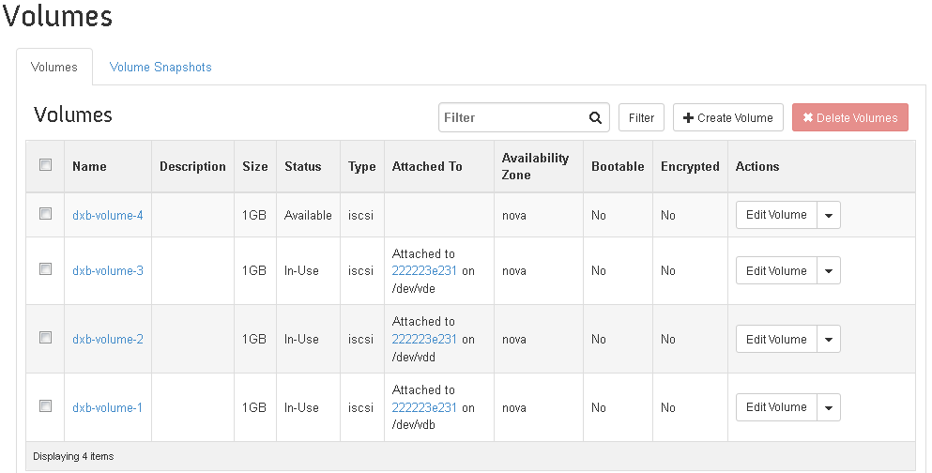

### lv created on cinder-volume

Automated generate three volumes on controller node.



Automated generate one lv on cinder-backup node.



### iscsi sessions

iscsi sessions on compute node. Two sessions for controller node(10.228.254.143), it means that two iscsi targets have been attached to a instance. One session for cinder-backup node(10.228.254.151), it means that one iscsi target has been attached to a instance.



### Instance’s disks



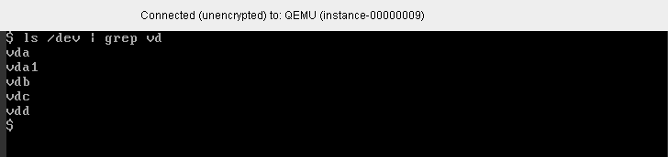

Now we can partition and format those disks (vdb,vdc,vdd).